SIMPAS INTERNATIONAL SYMPOSIUM (SIMPAS-2023)
25-28 August 2023
Physical: Suzhou
Registration fee:
Registration Fee | Physical
Regular | RMB3000 (AUD700)
Student | RMB2000 (AUD500)
Keynote Speakers | 0
- Please follow this link for registration (available in both AUD and RMB).
- Last date for Regular Registration: Tuesday 22 Aug 2023
- Late registration fee including on-site Registration: +￥500 (extra)
- Instructions for payment in AUD (for overseas attendees) can be found from the website
- Please submit either an online registration form or the registration form below to ARC.Hub.Secretariat@monash.edu

A: Attendee Details (参会者基本信息)
- Title： _______________
- Name： _______________
- Organization：_______________
- E-Mail： _______________
- Phone： _______________

B: Options
Has your abstract been submitted (是否已递交文章摘要)? Yes ( ) No ( )
Will you be having a presentation (applicable to all participants)? Yes ( ) No ( )
(是否是做口头报告-适合所有注册者）

Will you be having a Poster (applicable to physical participants)? Yes ( ) No ( )
（是否有墙报-只适合线下注册者）

Will you be having a poster and agree to have your poster posted online? Yes ( ) No ( )
（是否有墙报且允许网上发布-只适合所有注册者）

Will you be joining for lunch and dinner?

Date | 25th | 26th | 27th | 28th
Lunch | --- | Yes/No | Yes/No | ---
Dinner | Yes/No | Yes/No | Yes/No | Yes/No

Will you be joining the tour on 28 Aug? Yes ( ) No ( )

C: Registration Fee (注册金额)
Physical attendance registration (线下参会者注册) Yes ( )

RMB （人民币）: Regular （普通- RMB 3000 ( ) Student（学生- RMB 2000 ( )
Please refer to the enclosed RMB payment method (参照附页的人民币付款方式)

AUD（澳元）: Regular （普通）- A$700 ( ) Student（学生）- A$500 ( )
Please refer to the enclose AUD Payment Method (参照附页的澳元付款方式)

D: Invoice Information (发票信息)

Invoice title/name (发票抬头): ________________________________________
Invoice organization name Tax ID number (发票单位税号): _______________________________
Please select one of the options below (注：二选一，请根据实际情况填写):
- Electronic receipt (电子收据) Yes ( )
    - Provide E-mail(提供电子信箱):____________________________________________
- Paper-based receipt(纸质收据) Yes ( )
  - Provide E-mail (提供电子信箱): _____________________________________
  - Provide mailing address(提供邮件详细地址): __________________________
  - Provide contact number(联系人电话):

Please make your payment and email your registration form to ARC.Hub.Secretariat@monash.edu

Payment Methods are enclosed next page

Payment Methods
(The detailed payment Instructions are available online: )
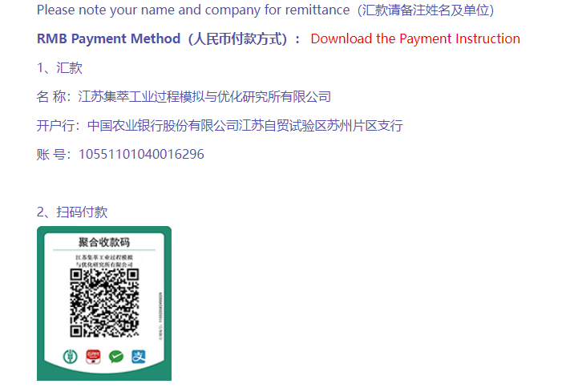
Please note that your name and company for remittance (汇款请备注姓名和单位)

