5th International Symposium on Computational Particle Technology
&
Frontier Forum of AI and Process Engineering

Registration fee:

Registration Fee | Physical
Regular | RMB3500 (A$700)
Student | RMB2500 (A$500)
Keynote Speakers | 0

- The Registration Fee includes conference materials, all lunch, dinner, banquet and tea breaks during symposium period.
- Deadline for Regular Registration: Thursday 20 Aug 2026
- Late registration fee including on-site Registration: +￥500 (extra)
- Instructions for payment in AUD (for overseas attendees) can be found from the website
- Please submit either an online registration form or the registration form below to Secretariat.CPT@simpas.cn

A: Attendee Details (参会者基本信息)

- Title： _______________
- Name： _______________
- ID/Passport： _______________
- Organization：_______________
- E-Mail： _______________
- Phone： _______________

B: Options

Has your abstract been submitted (是否已递交文章摘要)? Yes ( ) No ( )

Will you be having a presentation (applicable to all participants)? Yes ( ) No ( )
(是否是做口头报告-适合所有注册者）

Will you be having a Poster (applicable to physical participants)? Yes ( ) No ( )
（是否有墙报-只适合线下注册者）

Will you be having a poster and agree to have your poster posted online? Yes ( ) No ( )
（是否有墙报且允许网上发布-只适合所有注册者）

Will you be joining for lunch and dinner?

Date | 21st | 22nd | 23rd | 24th
Lunch | Yes/No | Yes/No | Yes/No | Yes/No
Dinner | Yes/No | Yes/No | Yes/No | Yes/No

C: Registration Fee (注册金额)

Physical attendance registration (线下参会者注册) Yes ( )

RMB （人民币）: Regular （普通）- RMB 3500 ( ) Student（学生）- RMB 2500 ( )
Please refer to the enclosed RMB payment method (参照附页的人民币付款方式)

AUD（澳元）: Regular （普通）- A$700 ( ) Student（学生）- A$500 ( )
Please refer to the enclose AUD Payment Method (参照附页的澳元付款方式)

D: Invoice Information (发票信息)

Invoice title/name (发票抬头):

Invoice organization name Tax ID number (发票单位税号):

Please select one of the options below (注：二选一，请根据实际情况填写):

Provide E-mail(提供电子信箱):

Please make your payment and email your registration form to Secretariat.CPT@simpas.cn

Payment Methods are enclosed next page

Payment Methods
The detailed payment Instructions are available online:
Please note your name and company for remittance (汇款请备注姓名及单位)
RMB Payment Method (人民币款方式) : Download the Payment Instruction
1、汇款

名 称:江苏集萃工业过程模拟与优化研究所有限公司开户行:中国农业银行股份有限公司江苏自贸试验区苏州片区支行账号:10551101040016296

2、扫码付款
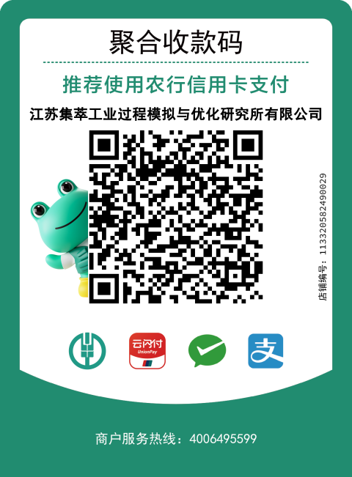

AUD Payment Method (澳元款方):Download the Payment Instruction
Beneficiary Name and Bank Account:
·China Construction Bank，Suzhou Branch
·SWIFT BIC: PCBCCNBJJSS
·Bank Address: 1F East Block Juzhong Ginza NO.122 Wangdun Road Suzhou Industrial Park China
·Beneficiary Account No.：32250198883609829006
·Beneficiary Name：JITRI JIANGSU IPMO
·Beneficiary Address: 19th floor/Building B, No. 388 Ruoshui Road, Suzhou industrial park, Suzhou, Jiangsu Province, P.R
China, 215000

